1/26/20

PySplot Normalization Tutorial

1. Run the PySplot code in a Python code environment (Spyder, for example). You will see the following window open.

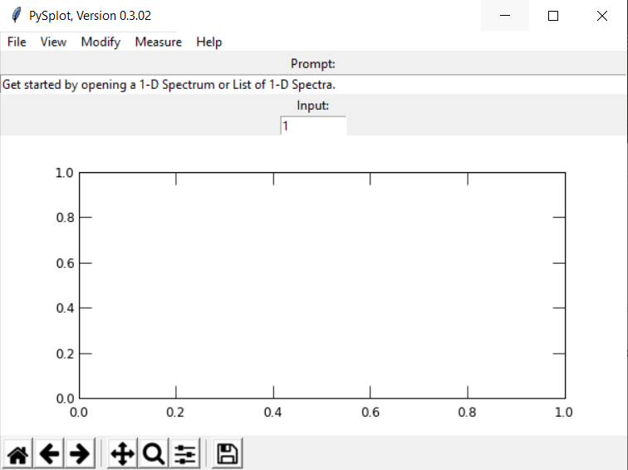

1. 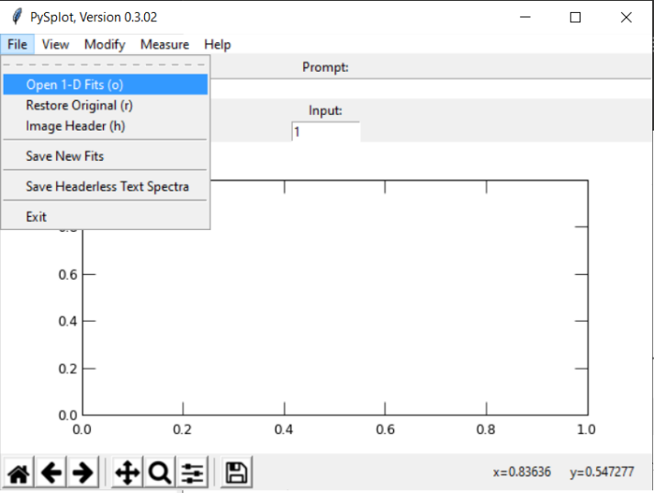To open a file, click on “File” in the top left of the window, then click on Open 1-D fits”. Alternatively, you can press “o” for a keyboard shortcut
2. 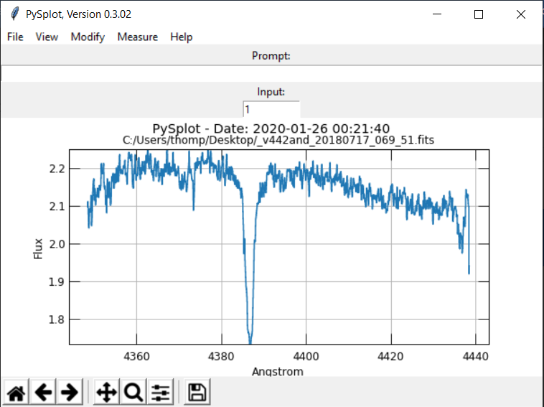After you select a proper file, the plot should be shown in the window. Now it’s time to normalize the data.
3. 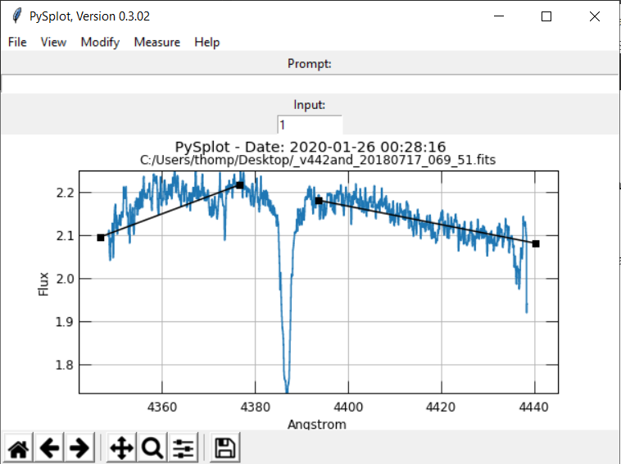Under the “modify” tab, click on “Set Continuum”. Then select an area that does not contain a “spike”, by selecting two points on the graph. Do this for every area that doesn’t contain a spike. The program only cares about where on the X-axis you place the points, it does not matter where you place them on the Y-axis.
4. 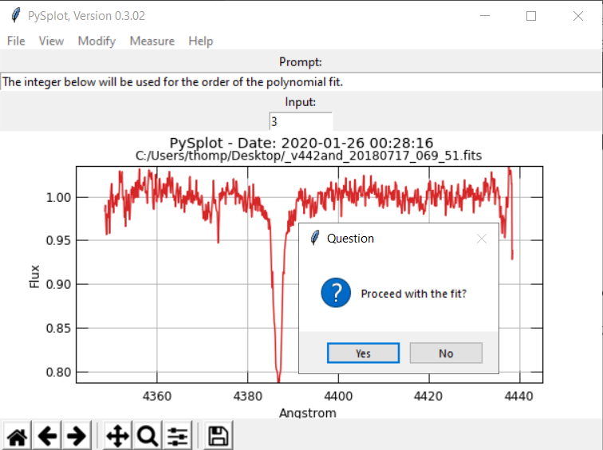Now select “Normalize” from the “Modify” tab. The plot should shift and change color, and the program will ask if you think the fit looks ok. If it does, then click yes. If not, click no, then change the “1” under “Input” to a “2”, and click normalize again. Repeat this as many times as needed until the plot looks satisfyingly straightend.
5. 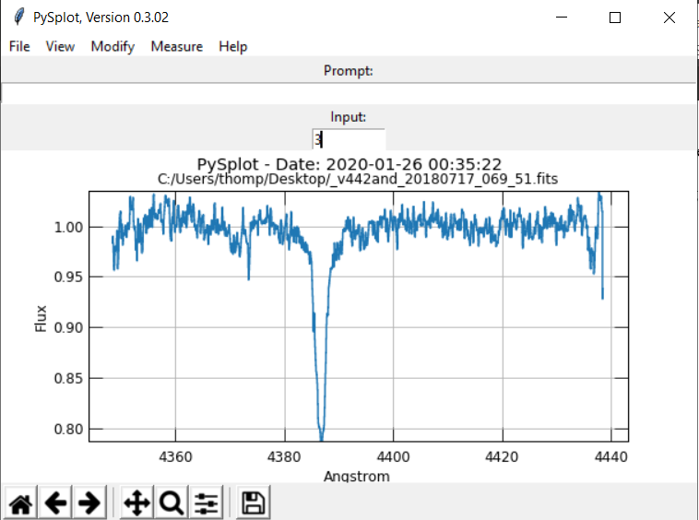When you do proceed with the fit, you’re all done! Click on “Save New Fits” under the “File” tab and you’re ready to do the next fit.